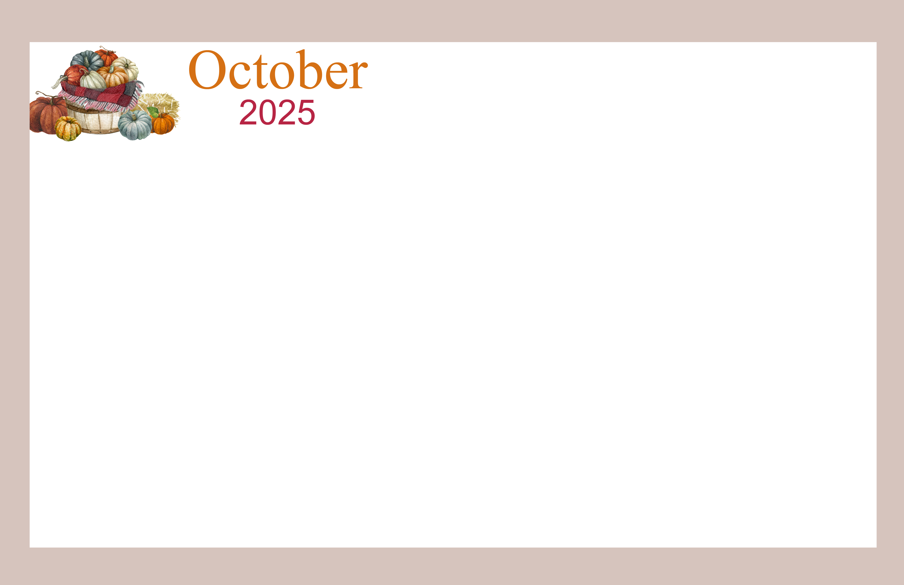  Suites, Garden Homes, and DLMA |  |  | 9:30 Seated Dance with Lauren (FH)  10:30 Hymn Sing (MPR)  2:00 Music with the  Weber’s (FH)  2:30 New Fall Menu Feedback Session (CR) | 9:30 Upper Body Strength (CR)  10:30 Bean Bag Toss (CR)  1:15 Hot Wax Treatment (Gym)  3:00 Shaw Festival Performance (FH) | 10:30 UNO (MPR)  2:30 Dominoes (MPR) | 10:00 Exercise Circle with Brandon (CR)  10:00 Fitness Support with Caleb (Gym)  1:30 Word Games (CR)  2:00 Crochet Club (FH)  2:30 Outdoor Strolls with Matt *Weather permitting (L)
10:30 Sunday Service with Chaplain Ellen (FH) | 9:30 Strength & Conditioning (CR)  10:30 Paint by Numbers (MPR)  1:30 Ladder Ball Toss (CR)  2:30 WPL Tech Support *Sign-up required  2:30 Spirit Circle with Chaplain Ellen (CR) | 9:30 Qi Gong (FH)  1:30 Bocce Ball (CR Hallway)  2:30 Discussion Game: Would You Rather? (CR)  3:30 UNO (MPR) | 9:30 Balloon Badminton (CR)  10:20 RC Communion Visits  10:30 Hymn Sing (MPR)  2:00 BINGO (MPR) | 9:30 Strength & Conditioning (CR)  10:30 Relax & Colour (MPR)  1:15 Hot Wax Treatment (Gym)  2:00 Music with Conn Smythe (FH) | 10:00 Baking: Thanksgiving Pumpkin Pies (FH)  1:30 Thanksgiving Flower Arranging (MPR) | 9:30 Exercise Circle with Matt (CR)  10:30 1:1 Fitness Support with Matt (Gym)  1:30 Bean Bag Toss (CR)
Thanksgiving Sunday  10:30 Sunday Service with Chaplain Lisa (FH) | Thanksgiving Day  9:30 Strength & Conditioning (CR)  10:30 Creative Painting (MPR)  2:00 Thanksgiving Tea  Social (FH) *Sign-up  required | Kindred Credit Union 10-11  10:00 Music with Kevin Coates (FH)  10:00-2:00 In-House Hearing Clinic *Sign-up required  1:30 Ladder Ball Toss (CR)  2:30 Current Events (MPR)  3:30 Dominoes (MPR) | 9:30 Seated Dance with Lauren (FH)  10:30 Hymn Sing (MPR)  10:30 Outing: Anna Mae’s *Sign-up required | 9:30 Strength & Conditioning (CR)  10:00 Worship with Janice (FH)  1:15 Hot Wax Treatment (Gym) | 9:30 Flexibility Fitness (CR)  10:30 Outdoor Strolls with Matt *Weather permitting (L)  1:30 Ring Toss (CR)  2:30 Suites BELL Info Session (MPR) | 9:30 Exercise Circle with Matt (CR)  10:30 1:1 Fitness Support with Matt (Gym)  1:30 Dominoes (MPR)
10:30 Sunday Service with Chaplain Lisa (FH)  2:00 Piano Drop-In with  Doug & Wilf (FH) | 9:30 Lower Body Strength (CR)  10:30 Craft: Suncatchers (MPR)  2:00 Diwali Celebration (FH)  2:30 Spirit Circle with  Chaplain Ellen (CR) | 9:30 Qi Gong (FH)  10:30 Erb & Good Funeral Planning Presentation (MPR)  12:00 Lunch Club: Oktoberfest Lunch (FH) *sign up required  1:30 Outing: Walmart *Sign-up required | 9:30 Balloon Badminton (CR)  10:30 Hymn Sing (MPR)  11:30 Outing: Anna Mae’s *Sign-up required  2:00 Music with a Record Day Combo (FH) | 9:30 Lower Body Strength (CR)  10:30 October Birthday Celebration (MPR)  1:15 Hot Wax Treatment (Gym)  2:30 BINGO (MPR) | 9:30 Flexibility Fitness (CR)  10:30 Pumpkin Decorating (MPR)  1:30 Jeopardy (CR)  2:30 UNO (MPR) | 10:00 Exercise Circle with Brandon (CR)  10:00 Fitness Support with Caleb (Gym)  1:30 Ladder Ball Toss (CR)  2:30 Word Games (CR)
10:30 Sunday Service with Chaplain Lisa (FH) | 9:30 Lower Body Strength (CR)  10:30 Creative Painting (MPR)  1:30 Ring Toss (CR)  2:30 Spirit Circle with  Chaplain Ellen (CR) | Kindred Credit Union 10-11  10:30 Memorial Service (FH)  1:30 Ladder Ball Toss (CR)  2:30 Poetry Reading (MPR)  5:00 Suites 6th Floor Dinner (MPR) | 10:30 Catholic Mass (FH)  2:00 Music with One More Time (FH) | 10:00 Uptown Swing Band (FH)  1:15 Hot Wax Treatment (Gym)  2:30 Travelogue: Ireland (CR) | Halloween  9:30 Flexibility Fitness (CR)  10:30 Halloween Social *Sign-up required  1:30 Word Games (CR)  2:30 Dominoes (MPR) | LEGEND  CR – Craft Room  MPR – Multipurpose Room  EDR - Education Room  FH – Fellowship Hall  L – Lobby  GR – Games Room  DR – Dining Room  FP – Front Patio
Contact Recreation: (519) 885 – 0090 Ext. 275 or recreation@parkwoodmh.com
Sunday | Monday | Tuesday | Wednesday | Thursday | Friday | Saturday
 |  |  | 1  Yom Kippur Begins | 2 | 3 | 4
5 | 6  Sukkot Begins | 7 | 8 | 9 | 10 | 11
12 | 13  Thanksgiving Day (Canada)  Indigenous Peoples’ Day  Columbus Day (U.S.) | 14  Simchat Torah Begins | 15 | 16 | 17 | 18
19 | 20 | 21 | 22 | 23 | 24 | 25
26 | 27 | 28 | 29 | 30 | 31  Halloween

ACTIVITY CALENDAR
OCTOBER 2025

